Media Contact:
Sarah Wynn Benton
BRAVE Public Relations
404.233.3993
sbenton@emailbrave.com

Alvin Ailey American Dance Theater Returns to Atlanta Feb. 16-19, 2023
for Five Exciting Performances at The Fox Theatre
World Premieres of Kyle Abraham’s Are You in Your Feelings? with a “Mixtape” of Soul, Hip-hop, and R&B and Jamar Roberts’ in a Sentimental Mood Set to Jazz Standards with Avant-Garde Twist
Company Premiere of Acclaimed Choreographer Twyla Tharp’s Roy’s Joys and
New Production of Survivors – Alvin Ailey’s 1986 Tribute to Nelson and Winnie Mandela
American Masterpiece Revelations is the Inspiring Finale of All Performances
ATLANTA – (Jan. 26, 2023) – Alvin Ailey American Dance Theater, beloved as one of the world’s most popular dance companies, returns to the Fox Theatre, February 16-19 for five show-stopping performances featuring eight different dance works as part of a 22-city North American tour. Led by Artistic Director Robert Battle, Ailey’s extraordinary dancers will move audiences with world and company premieres by Kyle Abraham, Jamar Roberts, and Twyla Tharp. In addition to two repertory favorites by Robert Battle, founder Alvin Ailey’s choreography is spotlighted with a new production of Survivors for the first-time ever, a dance from his legendary collaboration with Duke Ellington, and the must-see masterpiece Revelations as the finale of all performances.
“I look forward to being back on the Fox Theatre stage with the brilliance of Ailey’s dancers in this season’s repertory flowing with some of Alvin Ailey’s most memorable works while premiering choreography by Kyle Abraham and Jamar Roberts that explore Black culture and love through soulful and inventive musical journeys,” said Artistic Director Robert Battle. “For decades, Atlanta’s unique cultural and civic contributions have served as an inspiration and a touchstone, and we’re proud to share our vision of resilience, artistry and the joy of connections on our return to a center of the Civil Rights Movement.”
The Thursday, Feb. 16 opening performance features acclaimed choreographer Twyla Tharp’s silky and sultry Roy’s Joys (1997), embodying the spontaneity of a 1940s and 50s jazz soundtrack by Roy Eldridge. Mixing vernacular dance with ballet and modern technique, Roy’s Joys exudes an easy, carefree energy that shows Tharp, a contemporary of Mr. Ailey, at her rollicking best. A new production of Survivors (1986), Alvin Ailey’s impassioned tribute to the profound courage and terrible anguish of Nelson and Winnie Mandela, will be seen this season for the first time since 1988. A soundtrack of Max Roach’s richly varied drumming and Abbey Lincoln’s powerful vocals sets the emotional tone for a work that presents a portrait of people transformed by injustice and lifts up those who resist oppression in any form. This program repeats on Saturday, Feb. 18 at 7:30 p.m.
2022-2023 Season Image. Alvin Ailey American Dance Theater’s Jacquelin Harris. Photo by Dario Calmese.
The Friday, Feb. 17 at 7:30 p.m. performance introduces acclaimed choreographer Kyle Abraham’s Are You in Your Feelings?, a celebration of Black culture, Black music, and the youthful spirit that perseveres in us all. Scored to a “mixtape” of soul, hip-hop, and R&B from featuring beloved musical artists like Jhené Aiko, Drake, Lauryn Hill, Kendrick Lamar, Jazmine Sullivan, and Summer Walker, the critically applauded work explores the connections among music, communication, and personal memory. Continuing to expand its diverse repertory, the Company will also present In a Sentimental Mood by Jamar Roberts, an intimate scene from the domestic life of a couple that becomes an exploration of love and desire. The work is set to an original composition by Duke Ellington and four jazz standards given an avant-garde twist by composer Rafiq Bhatia. Another highlight for the evening program is For Four, an exuberant quartet by Artistic Director Robert Battle that expresses the pent-up energy of a cooped-up world during the COVID-19 pandemic. It features four Ailey dancers and Wynton Marsalis’ delicious jazz score - written in 4/4 time. This program repeats on Sunday, Feb. 13 at 3 p.m.

The Family Matinee program on Saturday, Feb. 18 at 2 p.m. features one of Mr. Ailey’s most popular works: Night Creature, a bubbly champagne cocktail of a dance that celebrates the musical genius of Duke Ellington. The program also includes For Four and Robert Battle’s swirling duet Unfold, evoking the tenderness and ecstasy in Gustave Charpentier’s aria “Depuis le jour” sung by the incomparable Leontyne Price. The Family Matinee is followed by a free Q&A featuring Artistic Director Robert Battle.
The inspiring finale of all programs is Alvin Ailey’s masterpiece Revelations, acclaimed around the world for sending hearts soaring and lifting audiences to their feet. Since its debut in 1960, Revelations has been seen by more people than any other modern dance work and has moved audiences around the world through its powerful storytelling and soul-stirring music, evoking timeless themes of determination, hope, and transcendence. Springing from Ailey’s childhood memories of growing up in the south and attending services at Mount Olive Baptist Church in Texas, Revelations pays homage to the rich cultural heritage of the African-American and explores the emotional spectrum of the human condition.

On Friday, Feb. 17 at 10:30 a.m., Alvin Ailey American Dance Theater will host a school-time performance to introduce area students to the magic of Alvin Ailey’s must-see masterpiece Revelations. The hour-long educational experience, moderated by one of Ailey’s dancers, also features an excerpt of Are You in Your Feelings? and an insider’s look behind-the-scenes to inspire young people. It was as a student attending an Atlanta Ailey performance that Christopher R. Wilson, an Augusta, Georgia native who is now an Ailey dancer, began his journey into the world of dance that will led him to center stage at the Fox Theatre.
In addition to Alvin Ailey American Dance Theater’s captivating live performances, the Ailey organization is also excited to offer workshops, residencies, and auditions, including:
- Revelations: An Interdisciplinary Approach residency, Monday, Jan. 30 – Friday, Feb. 3 at Coretta Scott King Young Women's Leadership Academy and M. Agnes Elementary School. This innovative curriculum-based program utilizes Alvin Ailey’s signature masterpiece, Revelations, as the inspirational framework for a comprehensive study of language arts, social studies, and dance (more details to be announced).
- The Ailey School Auditions, Saturday, Feb. 11 at 10 a.m. (ages 12-15) and noon (ages 16-25) at Atlanta Ballet. The mission of The Ailey School is to make dance accessible to outstanding students through a curriculum of rigorous and diversified dance training. Nearly 80% of current Alvin Ailey American Dance Theater members received their pre-professional training from The Ailey School.
- Ailey Experience, returns to Atlanta on Saturday, Feb. 25 – Sunday, Feb. 26 (location to be announced), providing dancers ages 8 and up the opportunity to learn Horton, contemporary, and Latin jazz techniques from leading Ailey Extension instructors and former Alvin Ailey American Dance Theater company members. Presented in partnership with AREA Atlanta, the two-day workshop also teaches participants the rich history of Ailey’s signature style and how he changed the perception of American modern dance. No experience is necessary to join in the fun! For more information and to sign up please visit alvinailey.org/extension.
In 1958, Alvin Ailey and a small group of dancers took the stage in New York and forever changed American dance and culture. One of the country’s groundbreaking greats, his Company earned a reputation as one of the finest international ambassadors of American culture, promoting the uniqueness of the African American cultural experience and the preservation and enrichment of American modern dance. Now in its seventh decade, Alvin Ailey American Dance Theater continues to move forward under the leadership of Artistic Director Robert Battle, along with Associate Artistic Director Matthew Rushing, a renowned former dancer who is marking his 30th anniversary with Ailey this season. In 2014, Robert Battle accepted the Presidential Medal of Freedom, the nation’s highest civilian honor, on behalf of the late Alvin Ailey, a trailblazing artist who is the subject of the acclaimed documentary Ailey, currently streaming on Hulu.
Approved masks are strongly encouraged but not required. CDC guidelines state that bandanas, gaiters, or masks with vents/valves are not approved masks. The Fox Theatre is committed to following the latest health and safety protocols established by the CDC, local government, and unions. For the latest updates, please visit foxtheatre.org.
For more information on Ailey’s upcoming performances, visit www.alvinailey.org. For additional press materials, including bios, b-roll, and photos, members of the media may visit pressroom.alvinailey.org.
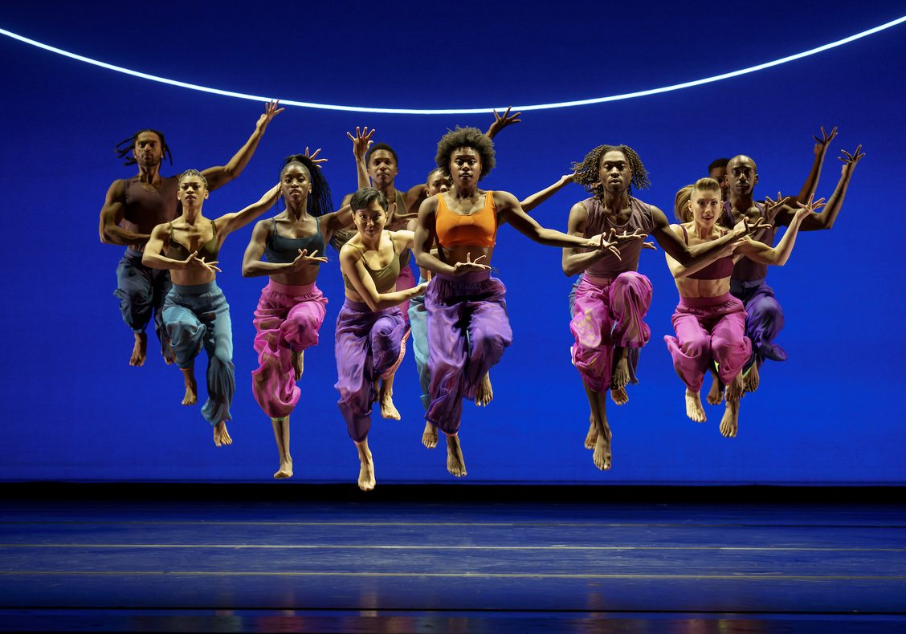
Please Credit Photo: Alvin Ailey American Dance Theater in Kyle Abraham's Are You in Your Feelings?. Photo by Paul Kolnik
Calendar Listing Information
Alvin Ailey American Dance Theater returns during Black History Month to center stage at The Fabulous Fox Theatre from Feb. 16-19. Led by Artistic Director Robert Battle, the highly-anticipated 2023 Atlanta engagement showcases the passionate spirit and extraordinary technique of Ailey’s dancers in premieres, new productions and repertory favorites. The uplifting finale of all five audience-captivating performances will be the must-see masterpiece Revelations. Tickets, starting at $29, are available at The Fox Theatre box office, 660 Peachtree Street NE, www.alvinailey.org, www.foxatltix.com or by calling 855-285-8499.
Ailey’s 2023 Atlanta Engagement Performance Dates and Times
Thursday, Feb. 16 at 7:30 p.m. – Roy’s Joys / Survivors / Revelations
Friday, Feb. 17 at 10:30 a.m. – Student Performance (moderated by Company member)
Speaking, Are You in Your Feelings? (excerpt), Speaking, Revelations, Speaking
Friday, Feb. 17 at 7:30 p.m. – In a Sentimental Mood, For Four/ Are You in Your Feelings? / Revelations
Saturday, Feb. 18 at 2 p.m. – Night Creature, For Four / Unfold / Revelations *
Saturday, Feb. 12 at 7:30 p.m. – Roy’s Joys / Survivors / Revelations
Sunday, Feb. 13 at 3 p.m. – In a Sentimental Mood, For Four/ Are You in Your Feelings? / Revelations
*Family Matinee followed by free Q&A featuring Artistic Director Robert Battle
Tickets
Tickets for Ailey’s 2023 Atlanta engagement from Feb. 16 to 19 are on sale starting at $29 at The Fox Theatre box office, 660 Peachtree Street NE, www.alvinailey.org, www.foxatltix.com or by calling 855-285-8499. Save 25% on tickets $39 or higher when you purchase by December 24 using code CHEER (limited 8 tickets per order and subject to availability).
- Student tickets are available for all performances except Saturday, Feb. 18 matinee for $15 or two for $25 with a valid student ID. Tickets must be purchased at the Fox Theatre box office (limit two per ID and subject to availability).

- Groups of 10 or more can receive up to 25% off by calling 404-881-2000 or completing a request form online (discounts applied to tickets regularly priced $39 or higher).
About Alvin Ailey American Dance Theater
Alvin Ailey American Dance Theater, recognized by U.S. Congressional resolution as a vital American “Cultural Ambassador to the World,” grew from a now‐fabled March 1958 performance in New York that changed forever the perception of American dance. Founded by Alvin Ailey, recent posthumous recipient of the Presidential Medal of Freedom – the nation’s highest civilian honor, and guided by Judith Jamison beginning in 1989, the Company is now led by Robert Battle, whom Judith Jamison chose to succeed her on July 1, 2011. Alvin Ailey American Dance Theater has performed for an estimated 25 million people in 71 countries on 6 continents – as well as millions more through television broadcasts, film screenings, and online platforms - promoting the uniqueness of the African‐American cultural experience and the preservation and enrichment of the American modern dance tradition.
In addition to being the Principal Dance Company of New York City Center, where its performances have become a year‐end tradition, the Ailey company performs annually at Lincoln Center for the Performing Arts, the John F. Kennedy Center for the Performing Arts in Washington, DC, the Auditorium Theatre in Chicago, The Fox Theatre in Atlanta, Zellerbach Hall in Berkeley, CA and at the New Jersey Performing Arts Center in Newark where it is the Principal Resident Affiliate), and appears frequently in other major theaters throughout the United States and the world during extensive yearly tours.
The Ailey organization also includes Ailey II (1974), a second performing company of emerging young dancers and innovative choreographers; The Ailey School (1969), one of the most extensive dance training programs in the world; Ailey Arts in Education & Community Programs, which brings dance into the classrooms, communities and lives of people of all ages; and The Ailey Extension (2005), a program offering dance and fitness classes to the general public, which began with the opening of Ailey’s permanent home—the largest building dedicated to dance in New York City, the dance capital of the world —named The Joan Weill Center for Dance, at 55th Street at 9th Avenue in New York City. For more information, visit www.alvinailey.org.

About the Fox Theatre
The Fox Theatre is one of Atlanta's premier venues for live entertainment, welcoming more than 250 performances a year in its 4,665-seat theatre. From concerts to ballets, comedy, and movies, the historic venue attracts more than 500,000 visitors annually. The theatre also hosts over 100 annual private events like wedding receptions, trade shows, corporate meetings, and association functions in two fabulous ballrooms. The Fox’s premium Marquee Club presented by Lexus, is a 10,000 sq. ft, three-story luxury bar accessible to all Club Level ticket holders or annual members of the Fox Theatre. As a 501(c)(3) nonprofit arts organization, the Fox Theatre stands today as a fiercely protected landmark and a nationally acclaimed theatre. The Fox Theatre proudly acknowledges its partners for their generous support: Coca-Cola, Lexus, Georgian Terrace Hotel, Georgia Natural Gas, and Regions Bank. Tickets for all events are available at FoxTheatre.org, or toll-free at 855-285-8499. Stay connected by following the Fox Theatre on social via @theFoxTheatre on Instagram, Twitter, and Facebook.

Notable accolades 2022 IEBA Theatre of the Year; 2021 Billboard Magazine #1 Highest Grossing Theatre Worldwide (5,000 seats or less); 2021 Pollstar Magazine #2 Theatre Worldwide in Ticket Sales; 2021 Venues Now Magazine #2 Year-End Top Stops (2,001-5,000 seats); 2019 Venues Now #1 Top Stop of the Decade Award for Tickets Sold.

Bank of America is Alvin Ailey American Dance Theater’s North American Tour Sponsor.

The 2023 National Tour is supported, in part, by the National Endowment for the Arts.

The Atlanta-Journal Constitution, Georgia-Pacific, Georgia Power, Home Depot, and Salesforce are all Ailey in Atlanta supporters.

